***Over The Wire Bandit***

1. ***ssh –***

* Secure Shell Protocol. It is used to remotely connect to a machine.
* ssh <username>@<server> -p <port>

1. ***pwd –***

* This command is one method to see, which is the current working directory.

1. ***ls –***

* List the files in the current folder (if the folder is not specified).
* It has optional flags such as -l and -a
* -l - which prints files in a long list format (additional information about a file)
* -a - which lists the hidden files also.

1. ***cat –***

* Reads files sequentially and writes them to standard output or in other words, prints the files content to the console.
* Syntax : cat < “filename” -- Reads the files

cat > “filename” -- whatever we type would be saved in this filename

1. ***cd –***

* changes the directory
* cd ../ 🡪 Moves us one directory back
* cd .. 🡪 goes to the parent directory
* cd / 🡪 goes to the root directory
* cd ~ 🡪 goes to the home directory (of the current user)

1. ***grep –***

* searches its input for lines containing a specific pattern defined by the user.
* when using the -v flag, a line with a defined pattern will not be printed.

1. ***find –***

* For finding non-executable files, the find command can be used. It has the -executable flag, which searches for executable files and allows operators like ‘!’ for negation.
* It has a flag for looking at file size in bytes -size <bytes>.
* It also has the option to only look at files -type f (no directories/non-executables).
* *The most common data encodings that are human-readable are ASCII and Unicode.*
* *To use a command on the output of another command (for example, the file command), we use the pipe | .*
* *To get the file size, we use the du command. Specifically, to get the size in bytes, we also use the -b flag. To look at all the files, including hidden ones, the -a flag is offered.*
* *The command file * would return the file type of every file the folder*

**Bandit Level 0**

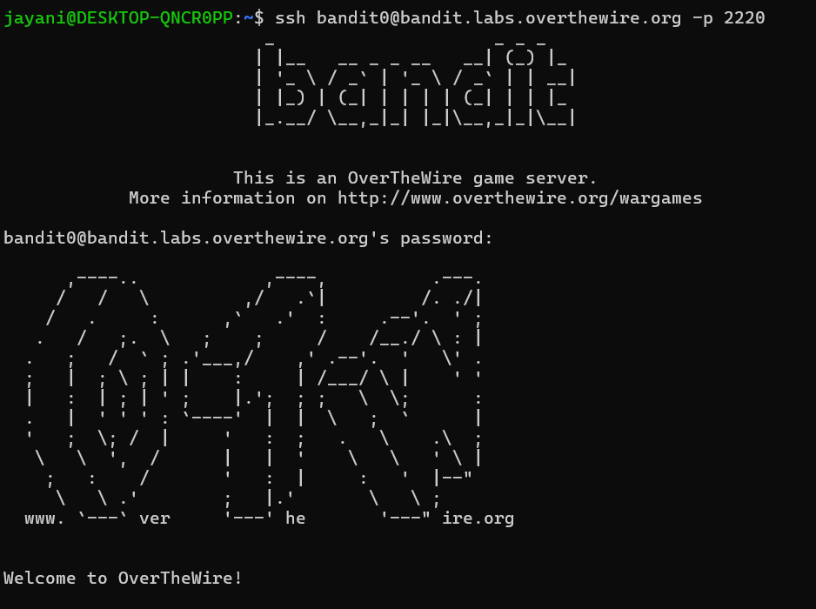

**Bandit Level 0 – Level 1**

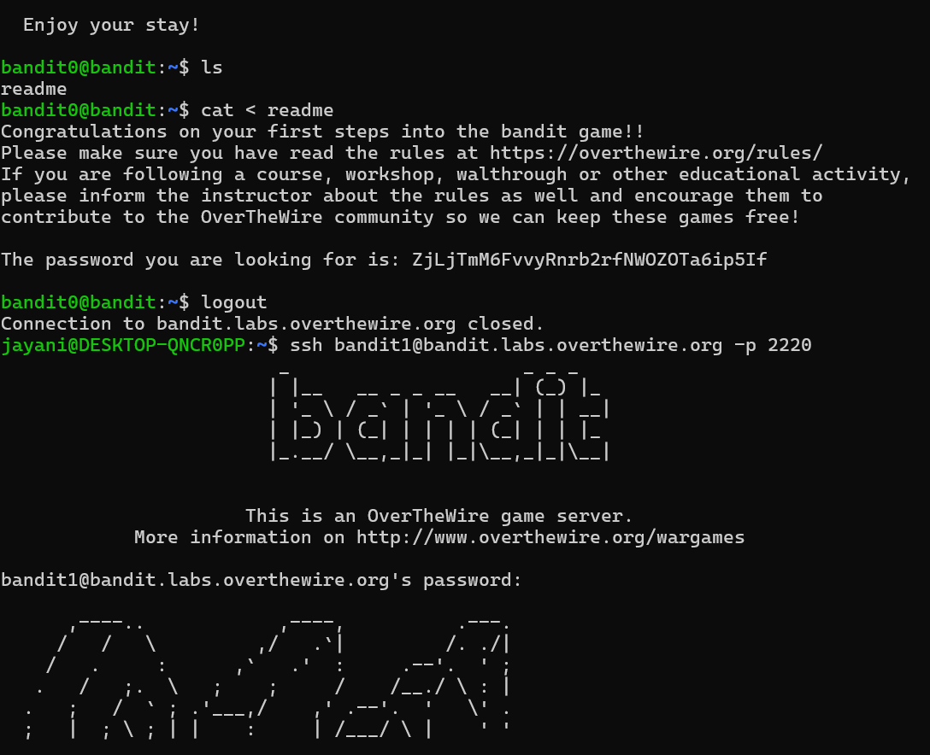

**Bandit Level 1 – Level 2**

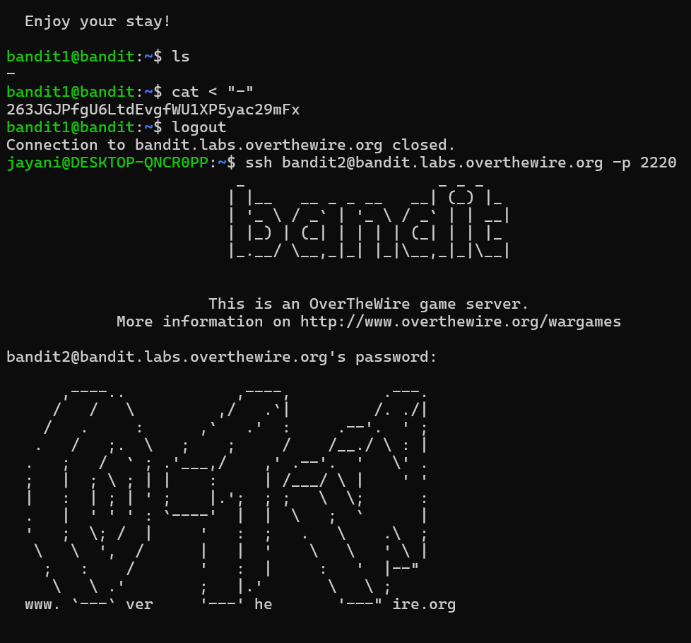

**Bandit Level 2- Level 3**

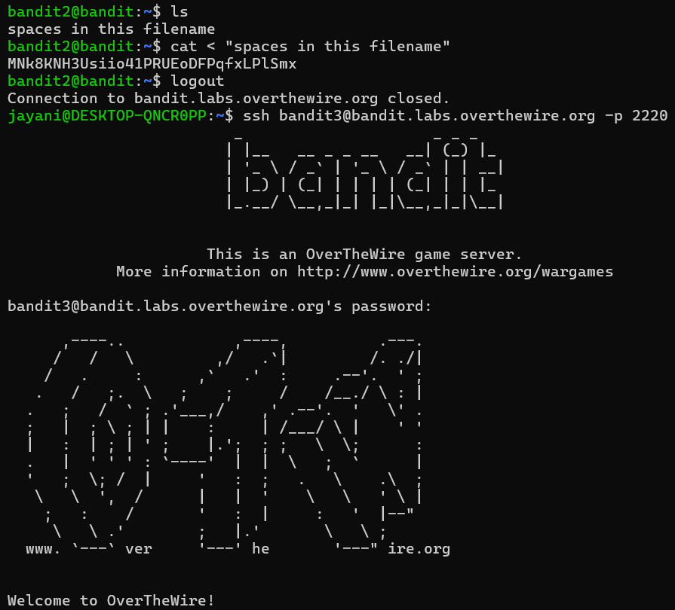

**Bandit Level 3 – Level 4**

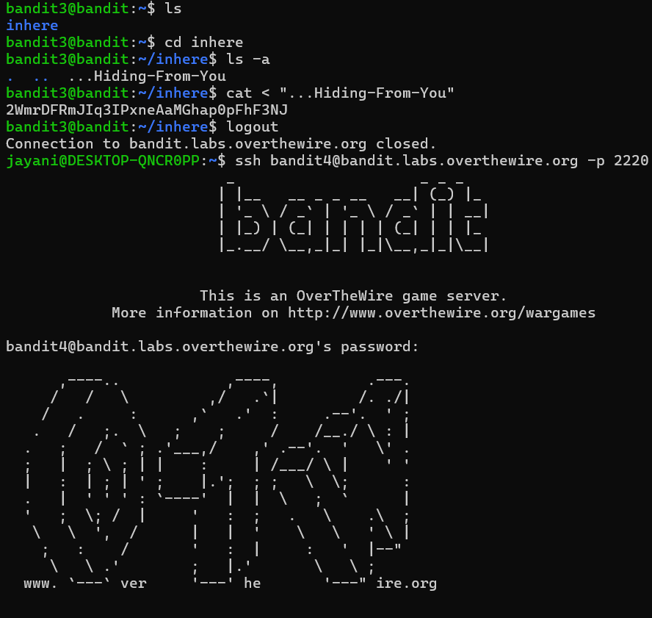

**Bandit Level 4 – Level 5**

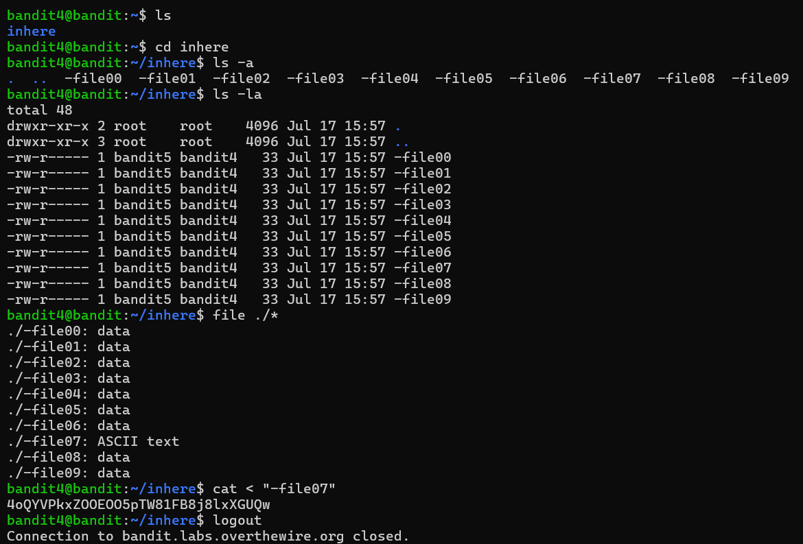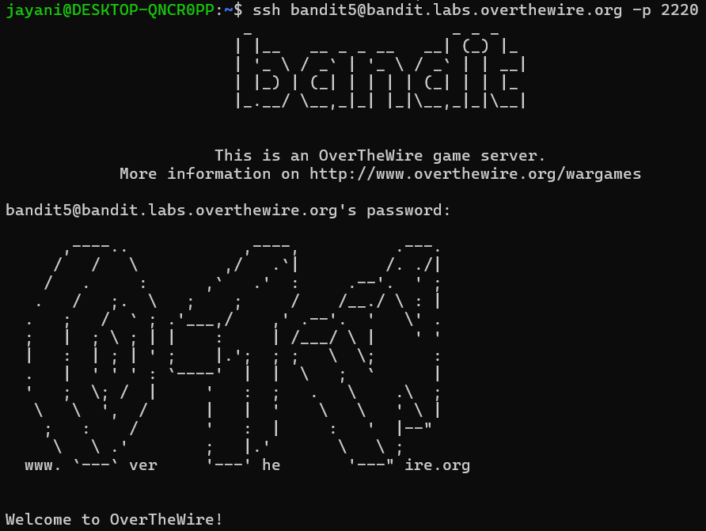

**Bandit Level 5 – Level 6**

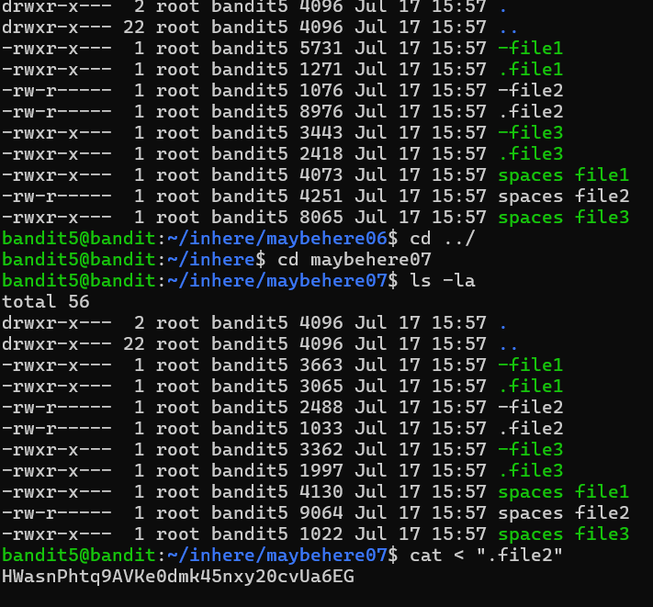

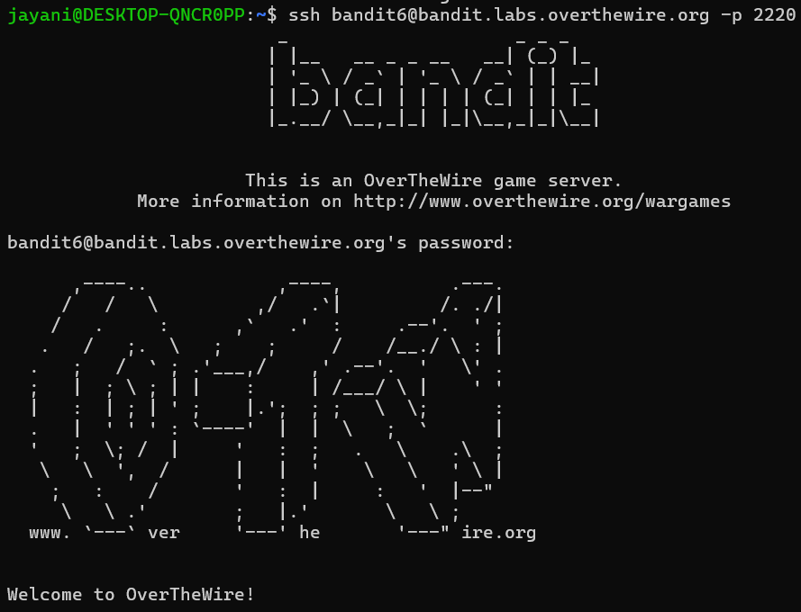

**Bandit Level 6 – Level 7**

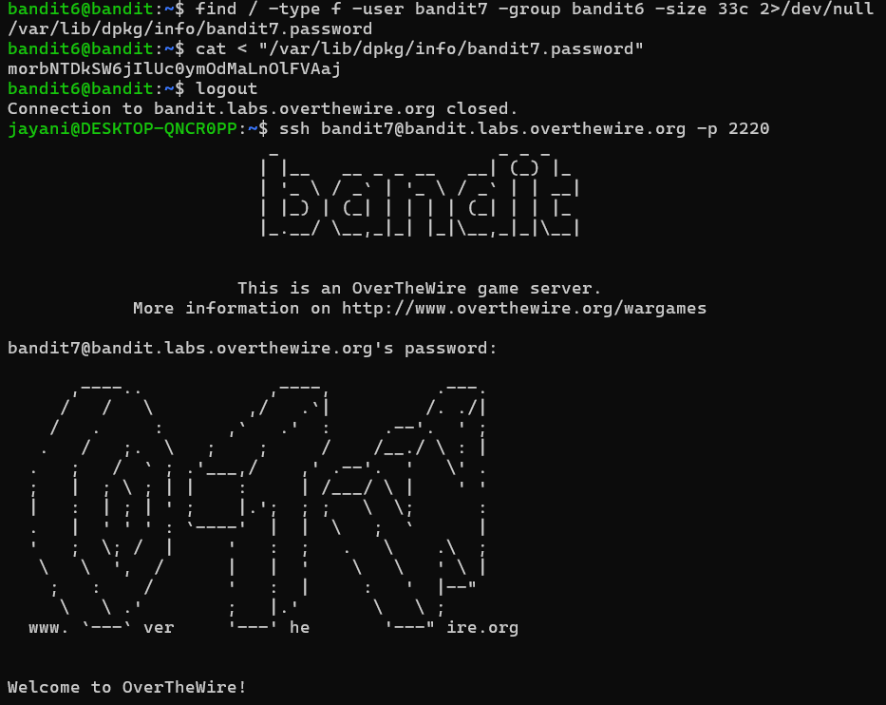

**Bandit Level 7 – Level 8**

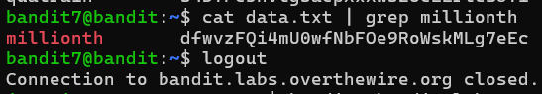

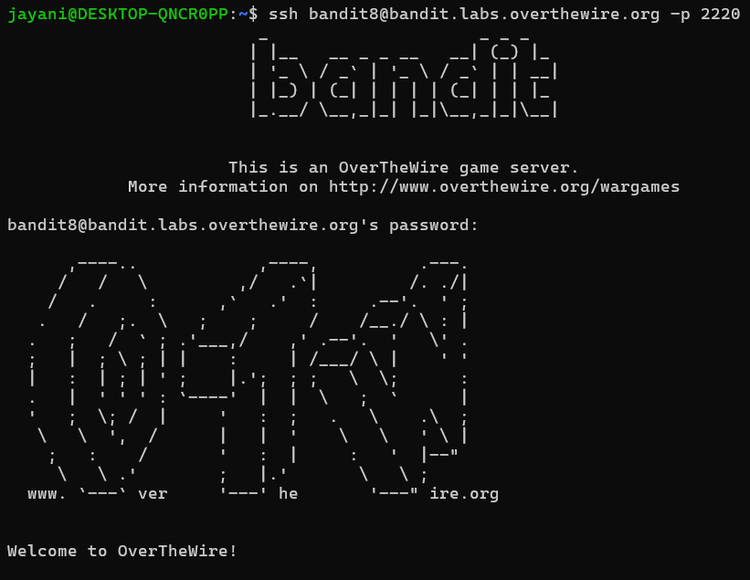

**Bandit Level 8 – Level 9**

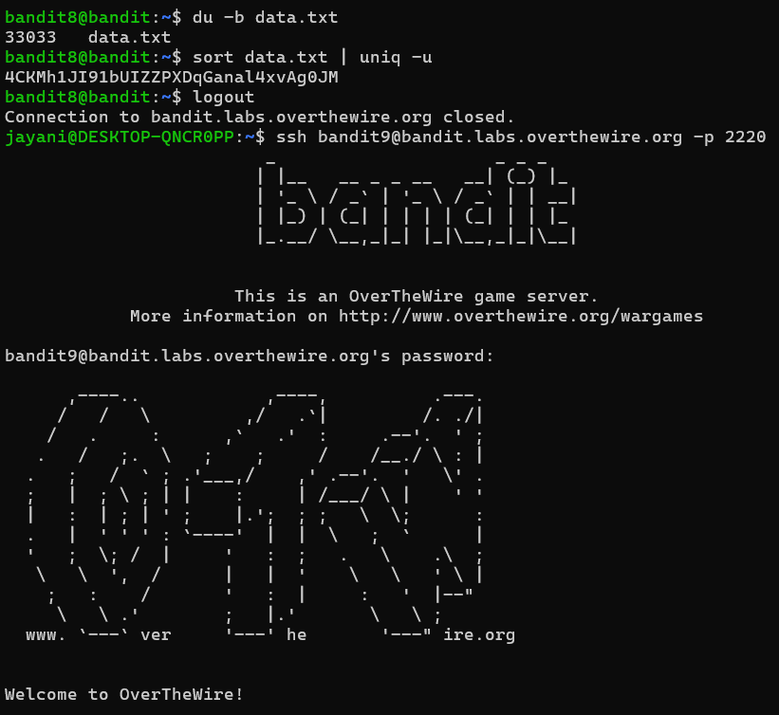

**Bandit Level 9 – Level 10**

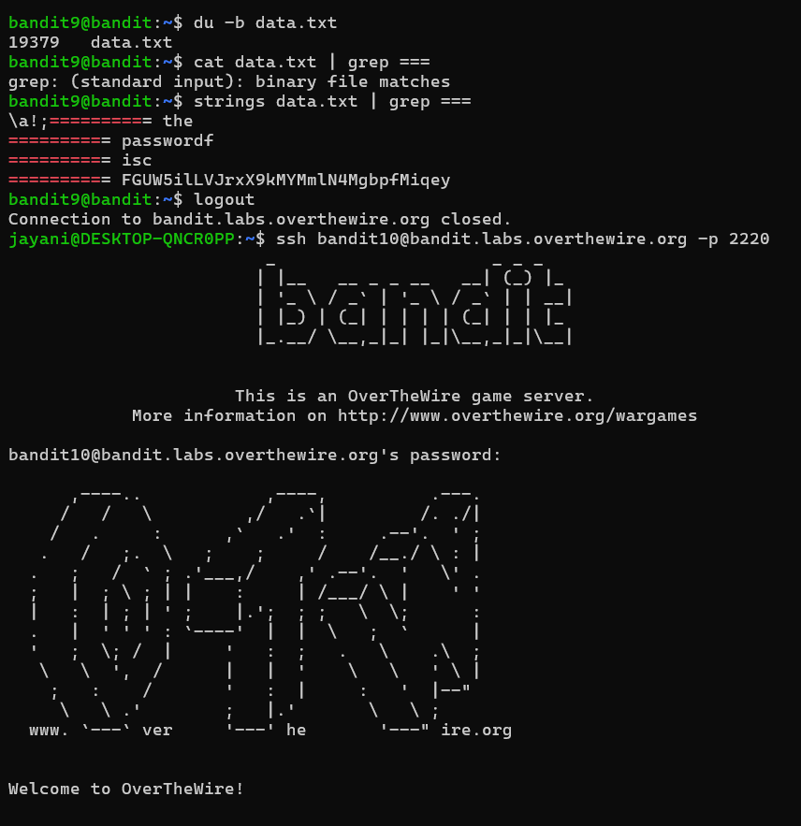

**Bandit Level 10 – Level 11**

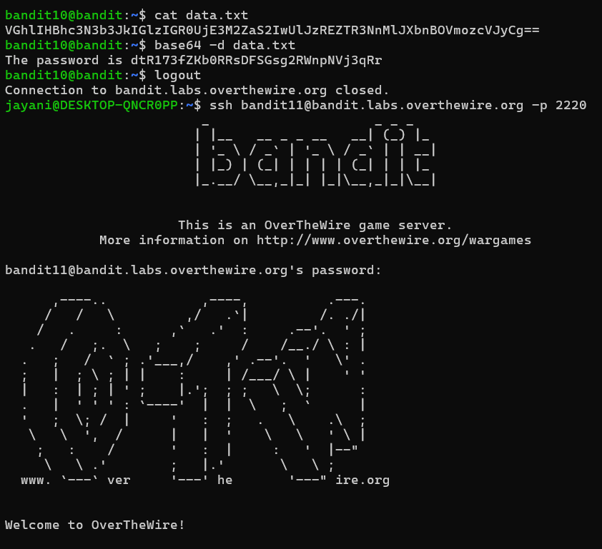

**Bandit Level 11 – Level 12**

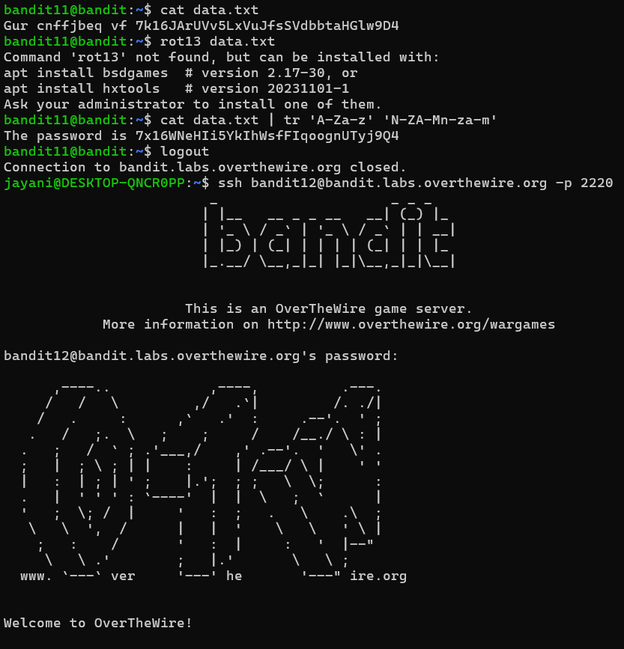

**Bandit Level 12 – Level 13**

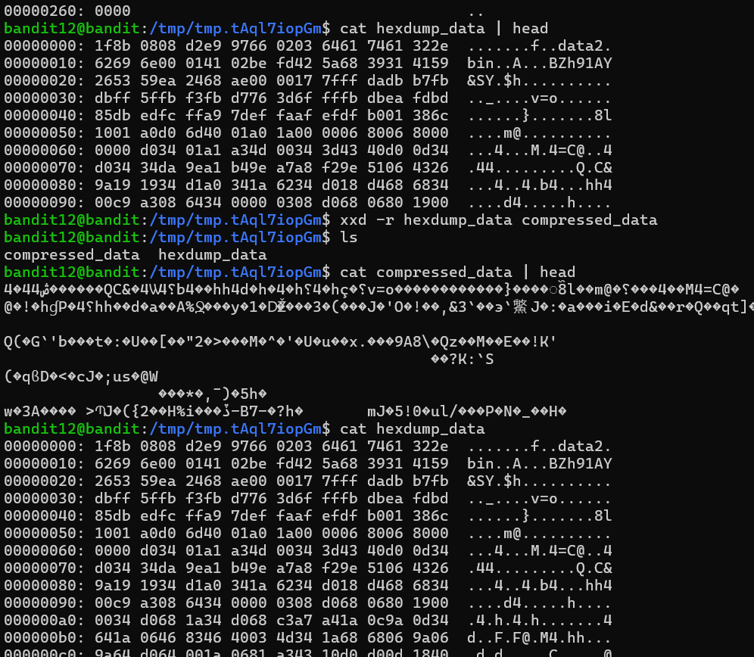

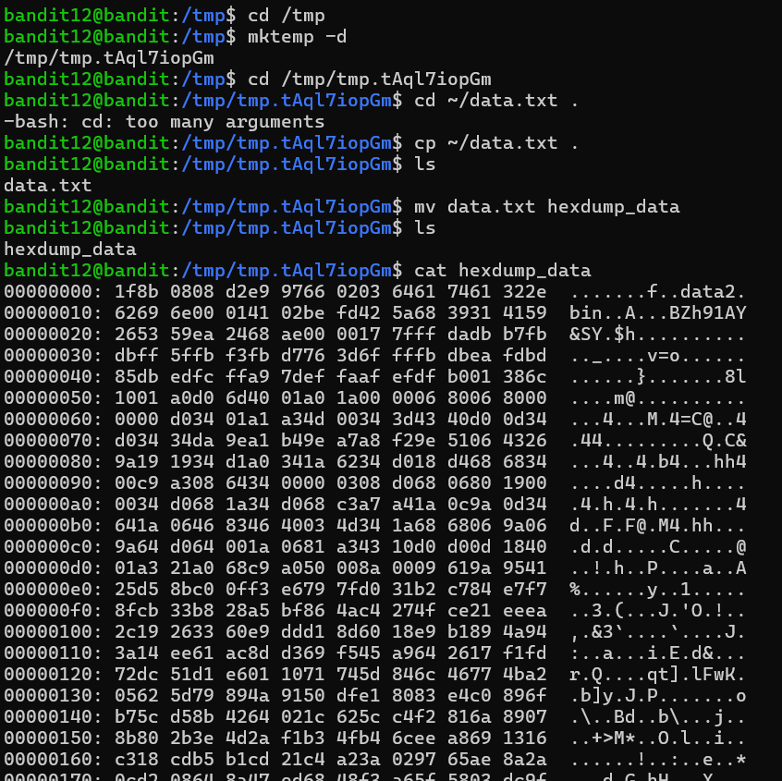

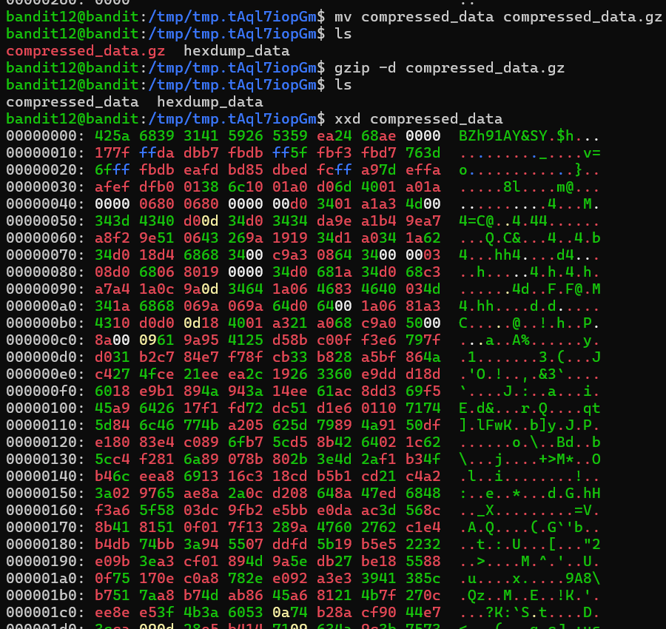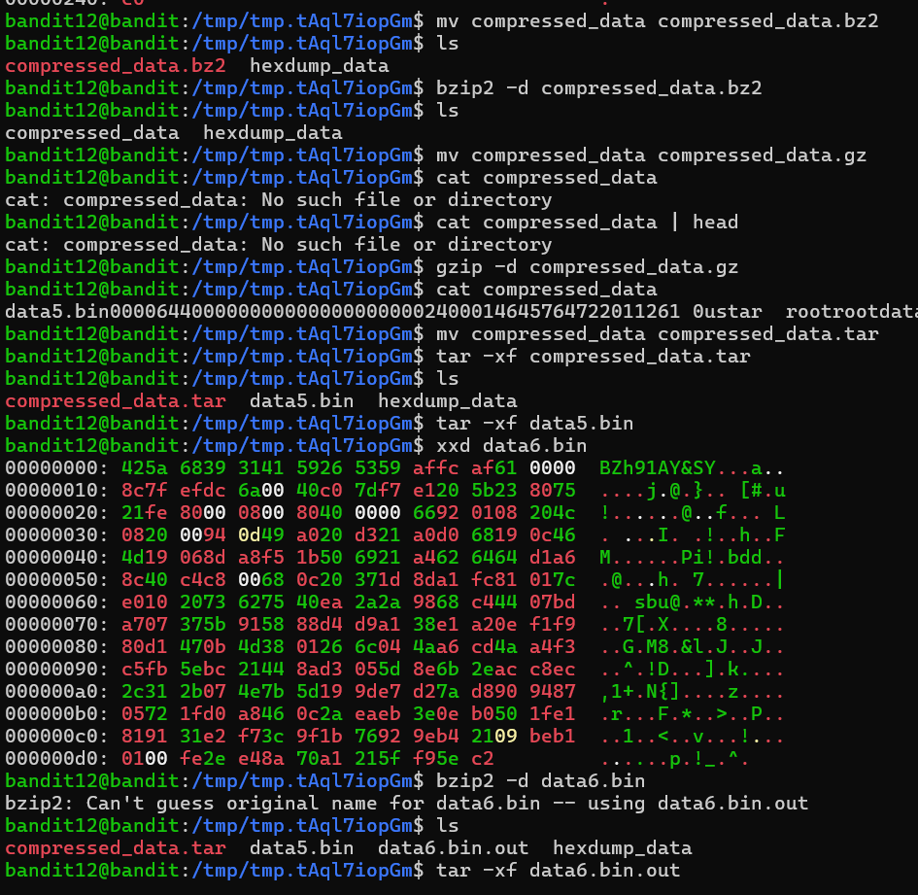

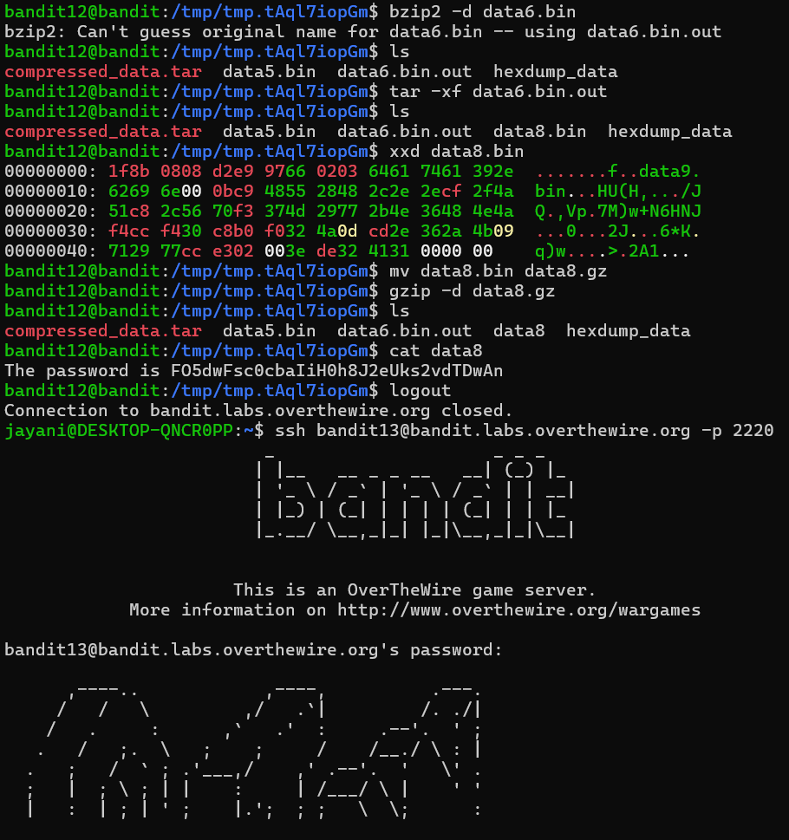

**Bandit Level 13 – Level 14**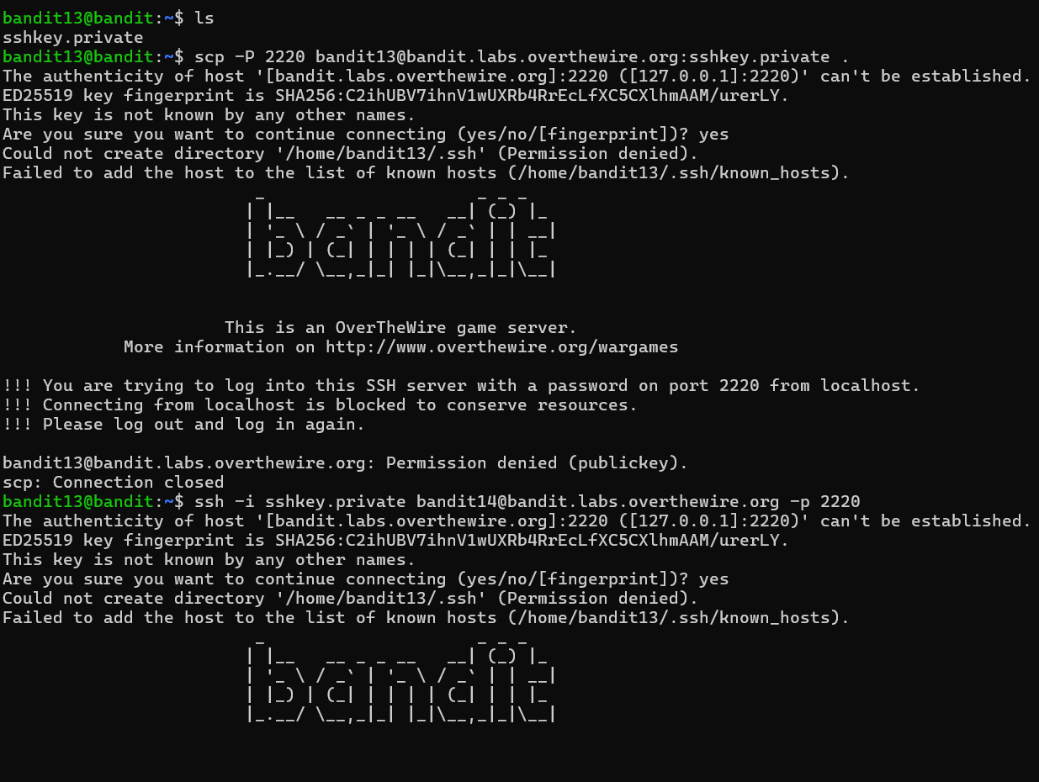

**Bandit Level 14 – Level 15**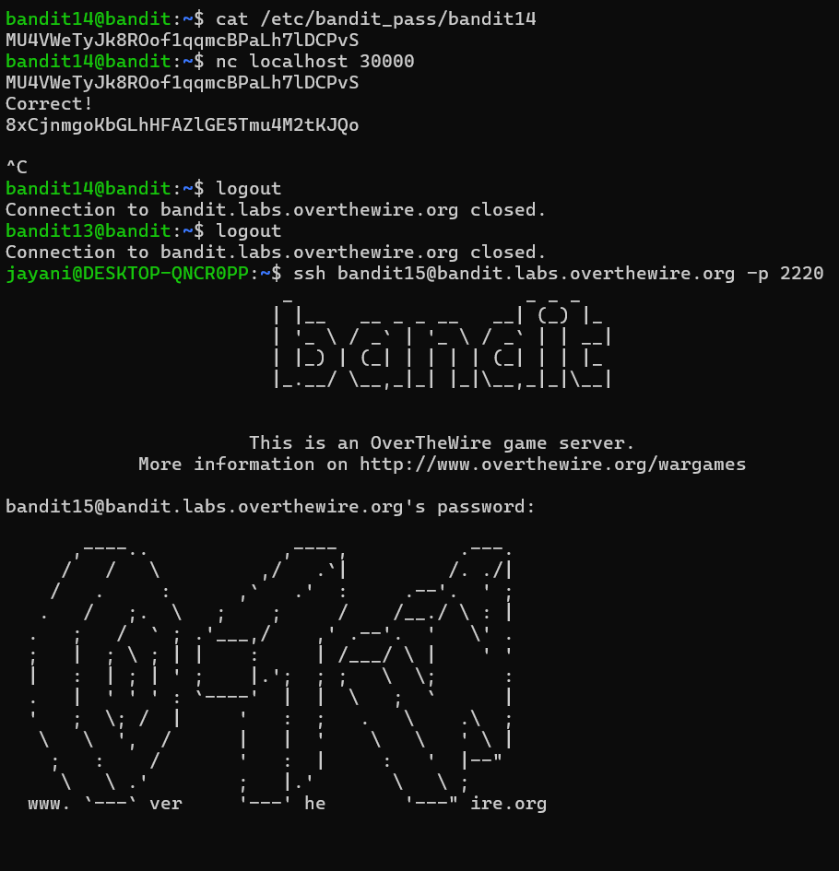

**Bandit Level 15 – Level 16**

